
Sreenidhi Institute of Science and Technology
H.T No
Regulations:
A20
(An Autonomous Institution)
Code No: 8E479 Date:28-August-2024(FN)

B.Tech II-Year II- Semester External Examination, August - 2024 (Supplementary)
COMPREHENSIVE TEST AND VIVA VOCE-IV (CSE)

Time: 3:00 Hours Max.Marks:70
Note: Answer Any 70 Questions.
Student can solve more than 70 questions, but maximum 70 marks will be awarded.
Calculator's are not allowed.

S.No | Question
1. | Let S be an NP-complete problem and Q and R be two other problems not known to be in NP. Q is polynomial time reducible to S and S is polynomial-time reducible to R. Which one of the following statements is true?  a) R is NP Hard b) R is NP Complete c) S is NP Hard d) S is NP Complete
2. | Consider two decision problems Q1, Q2 such that Q1 reduces in polynomial time to 3-SAT and 3-SAT reduces in polynomial time to Q2. Then which one of the following is consistent with the above statement?  a) Q1 is in NP,Q2 is NP Hard b) Q2 is in NP,Q1 is NP Hard  c) Both Q1 and Q2 are in NP Hard d) Both Q1 and Q2are in NP
3. | The problems 3-SAT and 2-SAT are  a) Both NP Complete b) Both in P c) NP Complete and P d) Undecideble and NP Complete
4. | -5 mod -3=  a) 1 b) 2 c) 3 d) 4
5. | Software layered technology are  a) quality focus,process models,functions & non-functions  b) process models,fuctions,quality focus & planning  c)quality focus,process models,planning & modeling  d)quality focus,process models,methods & tools
6. | What is planning in S/W engineering  a) analysis, design b) delivery, design  c) estimating, scheduling & tracking d)gathering information
7. | System Software Example  a) OS,compiler design b) system stimulation c)multimedia d)word processing
8. | Embedded S/W real-time Example  a) expert system b) game playing c) spreadsheet d)microwave oven
9. | 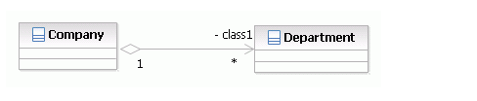  a) Aggregation b) Dependencies c) Association d) Composition
10. | 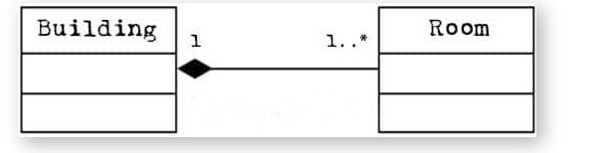  a) Aggregation b) Dependencies c) Association d) Composition
11. | Below diagram name is  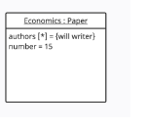a) component b) use case c) object d) sequence
12. | 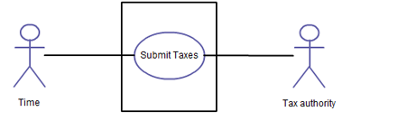  Above diagram name is  a) class b) object c) sequence d)use case
13. | Trigger transition model is  a) waterfall b)RAD c) concurrent development d)spiral
14. | NPL Stands for  a) Non-Procedural Language b) Non-performance Language  c) Network-procedural Language d) Netscape public Language
15. | Feasibility study categorize into  a) functional,non-functional & system b) technical,operational & Economic  c) functional,system & user d)technical, Non-functional & software
16. | waterfall model is also known as  a) Iterative b) NPL c) Component-based development d)classic life cycle
17. | UML relationships are  a) dependencies,generalization,association & realization  b) dependencies, generalization,extend & include  c) association,realization ,multiplicity & composition  d) association,realization,aggregation & composition
18. | Common modeling technique for Object diagram  a)workflow,operations b)links,objects  c)database sehema,logical sehema d)simple interface,collaboration
19. | Object diagram symbol is  a) 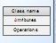 b) 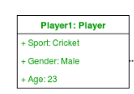 c)  d) 
20. | Actor Symbol is  a) 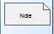 b)  c) 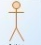 d) 
21. | Activity diagram is  a) the object that send & receice message b) flowchart message  c)activity to activity d) time-ordering of message
22. | Dependencies classifiers are  a) include,extend b) composition,aggregation c)generalization, association d)multiplicity, association
23. | 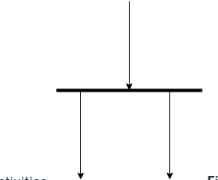  Above symbol is  a) decision b) connection c) fork d)join
24. | 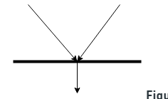  Above symbol is  a) decision b) connection c) fork d)join
25. | Component diagram common modeling techniques are  a) executables & libraries b) family’s & objects c) workflow & operations d) links & objects
26. | Deployment diagram consist of  a) class,attributes,operations b) processors,devices,connections  c) states,transitions,events d) objects,interface,collaboration
27. | State chart diagram known as  a) state machine,state transition b) static,object c) communication,interface d) state flow, state control
28. | Deployment diagram symbol is  a) 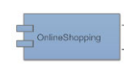 b) 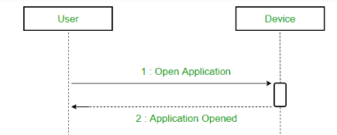 c) 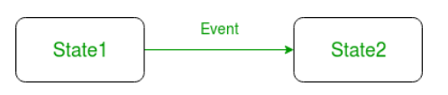 d) 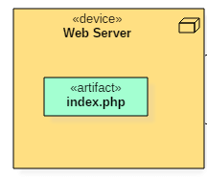
29. | Architecture of the database can be viewed as  (A) two levels. (B) four levels. (C) three levels. (D) one level.
30. | In a relational model, relations are termed as  (A)Tuples. (B) Attributes (C) Tables. (D) Rows.
31. | The database schema is written in  (A) HLL (B) DML (C) DDL (D) DCL
32. | In the architecture of a database system external level is the  (A) Physical level. (B) Logical level. (C) Conceptual level (D) view level.
33. | The database environment has all of the following components except:  (A) users. (B) separate files. (C) database. (D) database administrator.
34. | The language which has recently become the defacto standard for interfacing Application programs with relational database system is  (A) Oracle. (B) SQL. (C) DBase. (D)4GL.
35. | The way a particular application views the data from the database that the application uses is a  (A) module. (B) relational model. (C) schema. (D) sub schema.
36. | In an E-R diagram an entity set is represent by a  (A) rectangle. (B)ellipse. (C) diamond box. (D) circle.
37. | The method in which records are physically stored in a specified order according to a key field in each record is  (A)hash. (B) direct. (C) sequential. (D) all of the above.
38. | A subschema expresses  (A) the logical view. (B) the physical view. (C) the external view. (D) all of the above.
39. | Count function in SQL returns the number of  (A) values. (B) distinct values. (C) groups (D) columns.
40. | Which one of the following statements is false?  (A) The data dictionary is normally maintained by the database administrator.  (B) Data elements in the database can be modified by changing the data dictionary.  (C) The data dictionary contains the name and description of each data element.  (D) The data dictionary is a tool used exclusively by the database administrator
41. | E-R model uses this symbol to represent weak entity set ?  (A) Dotted rectangle. (B) Diamond (C) Doubly outlined rectangle (D) None of these
42. | SET concept is used in :  (A)Network Model (B) Hierarchical Model (C)Relational Model (D)None of these
43. | Relational Algebra is  (A) Data Definition Language . (B) Meta Language  (C) Procedural query Language (D)None of the above
44. | Key to represent relationship between tables is called  (A) Primary key (B) Secondary Key C) Foreign Key (D) None of these
45. | Which of the following is correct:  (A) a SQL query automatically eliminates duplicates.  (B) SQL permits attribute names to be repeated in the same relation.  (C) a SQL query will not work if there are no indexes on the relations (D) None of these
46. | It is better to use files than a DBMS when there are  (A) Stringent real-time requirements.  (B) Multiple users wish to access the data.  (C) Complex relationships among data.  (D) All of the above.
47. | The conceptual model is  (A) dependent on hardware. (B) dependent on software.  (C) dependent on both hardware and software . (D) independent of both hardware and software
48. | What is a relationship called when it is maintained between two entities?  (A) Unary (B) Binary (C) Ternary (D) Quaternary
49. | Which of the following operation is used if we are interested in only certain columns of a table?  (A) PROJECTION (B) SELECTION (C) UNION (D) JOIN
50. | Data stored in the database is processed or manipulated using data manipulation language commands as its name) ‘AS’ clause is used in SQL for  (A) Selection operation. (B) Rename operation. (C) Join operation. (D) Projection operation.
51. | (The logical implication expression A B, meaning if A then B,is equivalent to ¬A ∨ B)  The language used in application programs to request data from the DBMS is referred to as the  (A) DML (B) DDL (C) VDL (D) SDL
52. | Conceptual design  (A) is a documentation technique.  (B) needs data volume and processing frequencies to determine the size of the database.  (C) involves modelling independent of the DBMS.  (D) is designing the relational model.
53. | Perform the Subtraction 01000 - 01001 using 2’s complement method  a) 00001 b) 11111 c) 10101 d) 01010
54. | Convert the Octal number to Decimal number (237)8 = ( )10  a) 159 b) 237 c) 625 d) 259
55. | The logical sum of two or more product terms is called as  a) NAND operation b) POS c) OR operation d) SOP
56. | Convert the expression AB’C + A’BC + ABC’ to an equivalent POS  a) AB’C + A’BC + ABC’ b) (AB’C) + (A’BC) + (ABC’)  c) (A+B’+C) (A’BC) (ABC’) d) (A+B’+C) (A’+B+C) (A+B+C’)
57. | Convert a Binary number10101 to a Gray code  a ) 00010 b) 01000 c) 00101 d) 11111
58. | Convert Gray code to 10101 Binary  a ) 11001 b) 01000 c) 00101 d) 11111
59. | The Required flip-flop in T to D flip flop conversion  a ) SR flip-flop b) JK master slave c) D flip-flop d) none
60. | The Required flip-flop in JK to D flip flop conversion  a ) JK flip-flop b) SR flip-flop c) D flip-flop d) none
61. | Data in parallel form can be converted to Serial form using--- registers  a) PISO b) SISO c) SIPO d) PIPO
62. | The Propagation delay in---independent of number of flip-flops used  a) Asynchronous counter b) Synchronous counter c) trip counter d) none
63. | --- is a volatile memory is  a) SRAM b) DRAM c) both d) none
64. | Permanent memory of a computer is known as  a) RAM b) CD –ROM c) ROM d) none
65. | The SD of z = is  (a) 1 (b) 0 (c) 2 (d) 4
66. | The shape of Normal curve is  (a) Parabola (b) Straight line (c) bell (d) Rectangle
67. | The CL’s at 95% are  (a) ±1.96 (b) ±2.58 (c) ±2.33 (d) ±1.65
68. | The CL’s at 99% are  (a) ±1.96 (b) ±1.65 (c) ±2.33 (d) ±2.58
69. | For difference of 2 Means for small samples with sizes n1 and n2 we observe df with <% at  (a) n (b) n + n (c) n+n+2 (d) n+n-2
70. | The test statistic for difference of 2 Proportions for large sample is z = ____________  (a) (b) (c) (d)
71. | The test statistic for paired t – test is t = __________  (a) (b) (c) (d)
72. | r can be calculated by the following formula  (a) r = (b) r = (c) r = (d) r =
73. | The relation between coefficient of correlation r and regression coefficients a and b is  (a) r = ab (b) r² = a²b² (c) r = a²+b² (d) r =
74. | The non linear regression equation of y on x is _______________  (a) y=x (b) y=a+bx (c) x=c+dy (d) y²=x
75. | Demand curve always slopes ---- from left to right?  a) Upward b) Horizontal c) downward d) All
76. | In perfect competition market, seller is the?  (a) Price – Maker (b) Price changer (c) Price – Taker (d) Price Dictator
77. | Bank overdraft comes under?  a) Current Asset b) Current Liability c) Long term Liability d) Loss
78. | Provision for Bad debts treated against?  a) Creditors b) Debtors c) Loans d) Purchases
79. | Which is occupied highest need of order?  a) Basic b) Social c) self actualization d) Security
80. | Which is/are the remedy (ies) for controlling stress?  a) Exercise b) Pranayama c) Meditation d) All
81. | The tightest lower bound on the number of comparisons in the worst case for comparison based sorting is order of?  A) n B) n² C) nlogn D) nlog²n
82. | An unordered list contains n distinct elements. The number of comparisons to find an element in this list that is neither maximum nor minimum is?  A) Θ(nlogn) B) Θ(n) C) Θ(logn) D) Θ(1)
83. | Let W(n) and A(n) denote respectively, the worst case and average case running time of an algorithm executed on an input of size n. Which of the following is always true?  a) A(n) = Ω (W(n)) b) A(n) = Θ (W(n)) c)A(n) = O (W(n)) d)A(n) = o (W(n))
84. | Consider the following segment of C-code:  int j, n;  j = 1;  while (j <= n)  j = j*2;  The number of comparisons made in the execution of the loop for any n > 0 is:  Base of Log is 2 in all options.  (A) CEIL(logn) + 2 (B) n (C) CEIL(logn) (D) FLOOR(logn) + 2
85. | Which of the following statements is false?  (A) Optimal binary search tree construction can be performed efficiently using dynamic programming.  (B) Breadth-first search cannot be used to find connected components of a graph.  (C) Given the prefix and postfix walks of a binary tree, the tree cannot be re-constructed uniquely.  (D) Depth-first-search can be used to find the connected components of a graph.
86. | What is the time complexity for arranging the one pivot element in correct position in quick sort consider worst case?  a.) O (n) b) O (n²) c.)O (n log n) d.)O(logn)
87. | Let s be a sorted array of n integers. Let t(n) denote the time taken for the most efficient algorithm to determined if there are two elements with sum less than 1000 in s. which of the following statements is true?  a) t (n) is 0 (1) b) n < t (n) < n log2n c) n log2n < t (n) d.) t(n) is o (n)
88. | You have an array of n elements. Suppose you implement quicksort by always choosing the central element of the array as the pivot. Then the tightest upper bound for the worst case performance is  (A) O(n2) (B) O(nLogn) (C) Theta(nLogn) (D) O(n3)
89. | Let w be the minimum weight among all edge weights in an undirected connected graph. Let e be a specific edge of weight w. Which of the following is FALSE?  (A) There is a minimum spanning tree containing e.  (B) If e is not in a minimum spanning tree T, then in the cycle formed by adding e to T, all edges have the same weight.  C) Every minimum spanning tree has an edge of weight w. D) e is present in every minimum spanning tree.
90. | Given items as {value,weight} pairs {{40,20},{30,10},{20,5}}. The capacity of knapsack=20. Find the maximum value output assuming items to be divisible.  a) 60 b) 80 c) 100 d) 40
91. | Which of the following is false in the case of a spanning tree of a graph G?  a) It is tree that spans G b) It is a subgraph of the G  c) It includes every vertex of the G d) It can be either cyclic or acyclic
92. | Consider a complete graph G with 4 vertices. The graph G has ____ spanning trees.  a) 15 b) 8 c) 16 d) 13
93. | What is the time complexity of TSP?  a)O(n²) b) O(nlogn) c)O(n³) d)O(n2^{n})
94. | In a given graph for n=4(no.of vertices in a graph ), how many number of binary search trees can be generated  a)11 b) 12 c)13 d)14
95. | In reliability Design , formula for the maximum no.of devices(with duplication) connected to the system at ith stage is  a ) 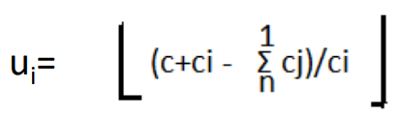 b) 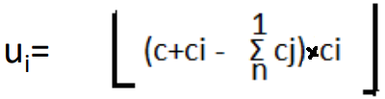 c) 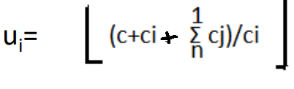 d)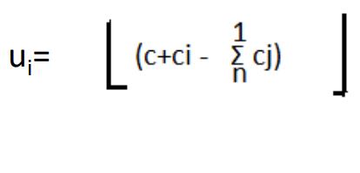
96. | For given Pair(pi,pj) and (pj,wj) Dominance Rule can be defined as  a) If (pi<=pj) and (wi<=wj) then (pi,wi) can be discarded  b) If (pi>=pj) and (wi<=wj) then (pi,wi) can be discarded  c) If (pi<=pj) and (wi>=wj) then (pi,wi) can be discarded  d) If (pi>=pj) and (wi>=wj) then (pi,wi) can be discarded
97. | Which data structure is used for implementing a LIFO branch and bound strategy?  a) stack b) queue c) array d) linked list
98. | Name the node which has been generated but none of its children nodes have been generated in state space tree of backtracking method.  a) E-Node b) Live node c) Dead Node d) Bounded node
99. | Name the node which is currently being generated  a) E-Node b) Live node c) Dead Node d) Bounded node
100. | Let G be a graph with ‘n’ nodes and let ‘m’ be the chromatic number of the graph. Then the time taken by the backtracking algorithm to color it is  a)O(nm) b) O(nmn) c)O(n+m) d)O(mn)

-- 00 -- 00 –

